TITLE OF ARTICLE TIMES NEW ROMAN 16PT, BOLD, UPPERCASE (spacing: before=0pt, after=6pt)
Author Full Name¹, The Corresponding Author Full Name^{1,2*} and Co-Author Full Name¹ Times New Roman 12pt, Capitalize Each Word
¹Faculty of Engineering, University of XXXXX, 12345, State, Country Times New Roman 11pt
²Affiliate 2 full address (if not the same as 1) Times New Roman 11pt

Date received: 0X/0X/2023 Date accepted: 0X/0X/2023 Times New Roman 10pt
*Corresponding author’s email: xxxxxxxxxxx Times New Roman 11pt
DOI: 10.33736/jcest.paperID.Year Times New Roman 10pt
Abstract — Abstract should include an introduction, background, methodology, value of findings, methodology, quantitative results, and conclusion. Times New Roman 11pt

Copyright © 2023 UNIMAS Publisher. This is an open access article distributed under the Creative Commons Attribution-NonCommercial-ShareAlike 4.0 International License which permits unrestricted use, distribution, and reproduction in any medium, provided the original work is properly cited.

Keywords: (5 Keywords) Times New Roman 10pt
- INTRODUCTION TIMES NEW ROMAN 12PT, BOLD, UPPERCASE (spacing: before=12pt, after=12pt)
Natural waste materials such as sludge, rice husk ash (RHA) and groundnut husk ash (GHA), coconut shell, and oil palm shell are mainly used as cement or fine and coarse aggregates replacer. These alternative materials are used to reduce waste and to provide alternative and greener materials in making concrete. Cement replacements are carried out using sludge, rice husk ash (RHA), and groundnut husk ash (GHA) [1,2,3]. As alternatives, natural aggregate replacements were either by using waste or agricultural by-products or solids such as coconut and palm oil shells, sawdust, recycled aggregates, mining tiling waste, and tyre [4]. Times New Roman 11pt
2.0 MATERIALS AND METHODS
Table 1 Composition of Plain and Rubberised Fibre Mortar Mixture Times New Roman 10pt
Mix Ref./  Percentage | Cement Content (kg/m³) | Fine Aggregate (kg/m³) | Crumb Rubber (kg/m³) | Water Content (kg/m³) | Fibre  (kg/m³)
F0 CR0 | 740.0 | 2035.0 | 0.0 | 399.6 | -
F0 CR10 | 740.0 | 1831.5 | 80.0 | 395.5 | -
F0 CR20 | 740.0 | 1628.0 | 159.8 | 391.5 | -
F0 CR30 | 740.0 | 1424.5 | 239.8 | 387.4 | -
Note: The F0 CR0 notations under the ‘Mix Ref./Percentage’ heading in col. 1 of Table 1 is for ease of identification where ’F’ is OPFF, the first ‘0’ is content % of fibre, ‘CR’ is crumb rubber, and the second ‘0’ is the content % of the crumb rubber. The same notations are applied in describing the samples for every batch. Times New Roman 9pt

Besides, the density is measured in accordance with BS 1881- 114 by weighing specimens’ masses (kg), which defines it as the mass of a unit volume of hardened concrete expressed in kilograms per cubic metre. Hence, the densities of the mortar cubes were calculated by dividing the mass (kg) by the dimensions of the cubes (m³) using Equation 1:

(1)

3.0 RESULTS AND DISCUSSION
3.1. Identification of CH and C-S-H as Pozzolanic Reaction Indication Times New Roman 11pt, Capitalize Each Word (subsection) (spacing: before=12pt, after=12pt)
3.1.1. Rubber content effects Times New Roman 11pt, italic, Sentence case (sub-subsection) (spacing: before=12pt, after=12pt)
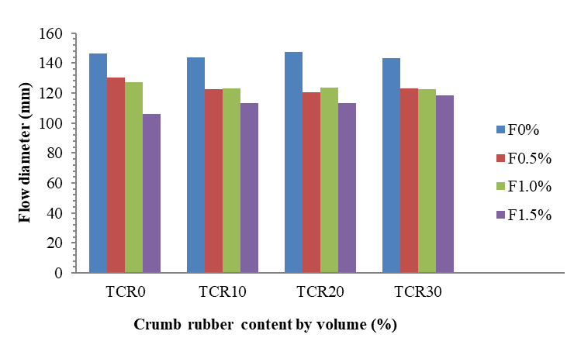
Figure 1 Workability of RFM as a function of rubber and oil palm fibre contents Times New Roman 10pt
4.0 CONCLUSION

Conflicts of Interest
The authors declare that there are no conflicts of interest regarding the publication of this paper.
Acknowledgement
The authors wish to acknowledge the xxxxx for supporting this work under the xxxxxx grant with the grant number xxxxxx.

References Times New Roman 12pt, Bold, Sentence case (spacing: before=12pt, after=12pt)
[1] Zhang, P., Li, D., Qiao, Y., Zhang, S., Sun, C., & Zhao, T. (2018). Effect of air entrainment on the mechanical properties, chloride migration, and microstructure of ordinary concrete and fly ash concrete. Journal of Materials in Civil Engineering, 30(10), 04018265. https://doi.org/10.1061/(ASCE)MT.1943-5533.0002456 Times New Roman 10pt
[2] Saha, A. K. (2018). Effect of class F fly ash on the durability properties of concrete. Sustainable environment research, 28(1), 25-31. https://doi.org/10.1016/j.serj.2017.09.001
[3] Ngohpok, C., Sata, V., Satiennam, T., Klungboonkrong, P., & Chindaprasirt, P. (2018). Mechanical properties, thermal conductivity, and sound absorption of pervious concrete containing recycled concrete and bottom ash aggregates. KSCE Journal of Civil Engineering, 22(4), 1369-1376. https://doi.org/10.1007/s12205-017-0144-6
[4] Asadi, I., Shafigh, P., Hassan, Z. F. B. A., & Mahyuddin, N. B. (2018). Thermal conductivity of concrete-A review. Journal of Building Engineering, 20, 81-93. https://doi.org/10.1016/j.jobe.2018.07.002

At least 10 references with DOI
The author can use the Simple Text Query form to generate DOI at https://doi.crossref.org/simpleTextQuery

